**MUFFAKHAM JAH COLLEGE OF ENGINEERING AND TECHNOLOGY**

**(Affiliated to OU)**

**Hyderabad – 500034**



**A MINI-PROJECT REPORT**

**ON**

**“Detection and Response”**

Submitted by

Syed Khaja Ikramuddin 1604-18-733-017

Syed Ibrahim Shakir 1604-18-733-019

Mohd Safiuddin 1604-18-733-036

**Department of Computer Science & Engineering**

**Muffakham Jah College of Engineering and Technology**

2020-2021

CERTIFICATE

Certified that the mini-project work entitled **“Detection and Response”** is a bona fide workcarried out by

**Syed Khaja Ikramuddin 1604-18-733-017**

**Syed Ibrahim Shakir 1604-18-733-01**9

**Mohd Safiuddin 1604-18-733-036**

The report has been approved as it satisfies the academic requirements in respect of mini-project work prescribed for the course.

……………...…………………………

**Dr. Krishna Keerthi Chennam**

**Mini Project Coordinator CSE-A**

**ABSTRACT:**

We are performing three different kind of cyber attacks.

A **denial of service** (DoS) event is a cyber attack in which hackers or cybercriminals seek to make a host machine, online service or network resource unavailable to its intended users. It is an attack where a computer is used to flood a server with TCP and UDP packets.We are using Low orbit ion cannon(LOIC) tool to perform DoS attack on a private aurl/server.

A **dictionary attack** is a systematic method of guessing a password by trying many common words and their simple variations.We preforming dictionary attack on wifi using aircrack-ng. Aircrack-ng is a network software suite consisting of a detector, packet sniffer, WEP and WPA/WPA2-PSK cracker and analysis tool for 802.11 wireless LANs.

A **malware attack**  executes unauthorized actions on the victim's system.The malicious software encompasses many specific types of attacks such as ransomware, spyware, command and control.The Metasploit Framework contains a suite of tools that you can use to test security vulnerabilities, enumerate networks, execute attacks, and evade detection.We are using this tool to spyware on a android device or other OS if possible

.

**TABLE OF CONTENTS:**

1.INTRODUCTION ……………………………………………… 1

1.1. Objective ……………………………………………………. 1

1.1.1 DoS attack ............................................................................. 1

1.1.2 Dictionary attack …………………………………………... 1

1.1.3 Malware attack …………………………………………….. 1

1.2. SYSTEM REQUIREMENTS ……………………………….. 3

1.2.1. Kali Linux OS ……………………………………………. 3

1.2.2 Wireless Adapter Capable of Packet Injection …………… 3

1.2.3 LOIC Tool ………………………………………………… 3

1.2.4 LAN ……………………………………………………….. 3

2. IMPLEMENTATION …………………………………………... 4

2.1 Dictionary Attack …………………………………………….. 4

2.2 Malware Attack ………………………………………………. 6

2.3 DoS Attack ……………………………………………………. 7

3.RESULT ………………………………………………………… 8

3.1 Dictionary Attack …………………………………………….. 8

3.2 Malware Attack ………………………………………………. 9

4. CONCLUSION …………………………………………………. 10

5. REFRENCES …………………………………………………… 11

**LIST OF FIGURES:**

Figure 1.2.1 Kali linux logo ………………………………………………………………… 6

Figure 2.1.1 Monitor Mode ………………………………………………………………..... 9

Figure 2.1.2. BSSID ……...………………………………………………………………..... 9

Figure 2.1.3 De authenticating …………………………………………………………..... 10

Figure 2.1.4 Handshake Captured ..………………………………………………………..... 10

Figure 2.2.1 Payload ………..……………………………………………………………..... 11

Figure 2.2.2 Metasploit Console …………………………………………………………..... 11

Figure 2.3 LOIC Tool ……………………………………………………………………..... 12

Figure 3.1 Key Found …..………………………………………………………………...... 12

Figure 3.2.1 Apps list …...………………………………………………………………..... 13

Figure 3.2.2 Snapshot ……………………………………………………………………..... 13

Figure 4.1 Types of Hackers ……………………………………………………………….. 14

**1.INTRODUCTION:**

**1.1Objective:**

*Ethical hacking* can prevent cyber-terrorism and terrorist attacks, ensuring the safety of the nation. Hackers can identify potential entry points from an attackers' perspective, allowing you the chance to fix them before an attack.Despite the rapidly evolving nature of cybercriminal activities, *ethical hackers* have a number of tools available at their disposal to create a solid line of defense.

**1.1.1DoS attack**

*DOS* is an*attack* used to deny legitimate users access to a resource such as accessing a website, network, emails, etc. or making it extremely slow. ... This type of*attack* is usually implemented by hitting the target resource such as a web server with too many requests at the same time**.**

 The goal of this attacks is to exhaust the target’s resources to create a denial-of-service.

**1.1.2Dictionary attack**

A *dictionary attack* is a method that consists of breaking into a password-protected computer or server (in this case a *Wi-Fi* network) by systematically entering every word in a *dictionary* as a password.*Dictionary attack* is a form of brute force attack technique for defeating a cipher or authentication mechanism by trying to determine its decryption key or passphrase by trying thousands or millions of likely possibilities, such as words in a *dictionary*.

*Dictionary attacks* often succeed because many people have a tendency to choose short passwords that are ordinary words or common passwords; or variants obtained, for example, by appending a digit or punctuation character.

**1.1.3Malware Attack**

The*purpose of malware* is to intrude on a machine for a variety of reasons.*Malware* or malicious software is certainly *dangerous*, and in some cases, it can be incredibly *dangerous*, and threaten to compromise your online banking, or lock away all your data so you can't reach it forever. It always pays to think before you click on any link or download any file, and to use a good antivirus app.

Ethical Hacking is an authorized practice of bypassing system security to identify potential data breaches and threats in a network. The company that owns the system or network allows [Cyber Security engineers](https://www.simplilearn.com/tutorials/cyber-security-tutorial/how-to-become-cyber-security-engineer) to perform such activities in order to test the system’s defenses. Thus, unlike malicious hacking, this process is planned, approved, and more importantly, legal

*Ethical hackers* aim to investigate the system or network for weak points that malicious *hackers* can exploit or destroy. They collect and analyze the information to figure out ways to strengthen the security of the system/network/applications.

**1.2System Requirements**

System requirements listed for a hardware device may include:

**1.2.1Kali Linux OS** Kali Linux is mainly used for advanced Penetration Testing and Security Auditing. Kali contains several hundred tools which are geared towards various information security tasks, such as Penetration Testing, Security research, Computer Forensics and Reverse Engineering. All tools like msfvenom and aircrack-ng are already installed in this operating system



Fig 1.2.1

**1.2.2Wireless Adapter Capable of Packet Injection**

Atheros AR9271: The Alfa AWUS036NHA is long-range network adapter and the standard other long-range adapters these chipsets are known to support monitor mode and packet injection and there are many other adapters which are capable but this one is recommended.

**1.2.3LOIC TOOL**

Low Orbit Ion Cannon(LOIC) designed by Praetex Technologies (open source) is required.LOIC is an [open-source](https://en.wikipedia.org/wiki/Open-source_software) network [stress testing](https://en.wikipedia.org/wiki/Stress_testing) and [denial-of-service attack](https://en.wikipedia.org/wiki/Denial-of-service_attack) application, written in [C#](https://en.wikipedia.org/wiki/C_Sharp_(programming_language)).

**1.2.4.LAN**

Small Local Area Network(LAN) has to be established before starting the attacks. At least 2 devices are required to connect to this Network for successful attack.

**2.IMPLEMENTATION:**

**2.1.Dictionary attack**

### Step1:  Start the wireless interface in monitor mode

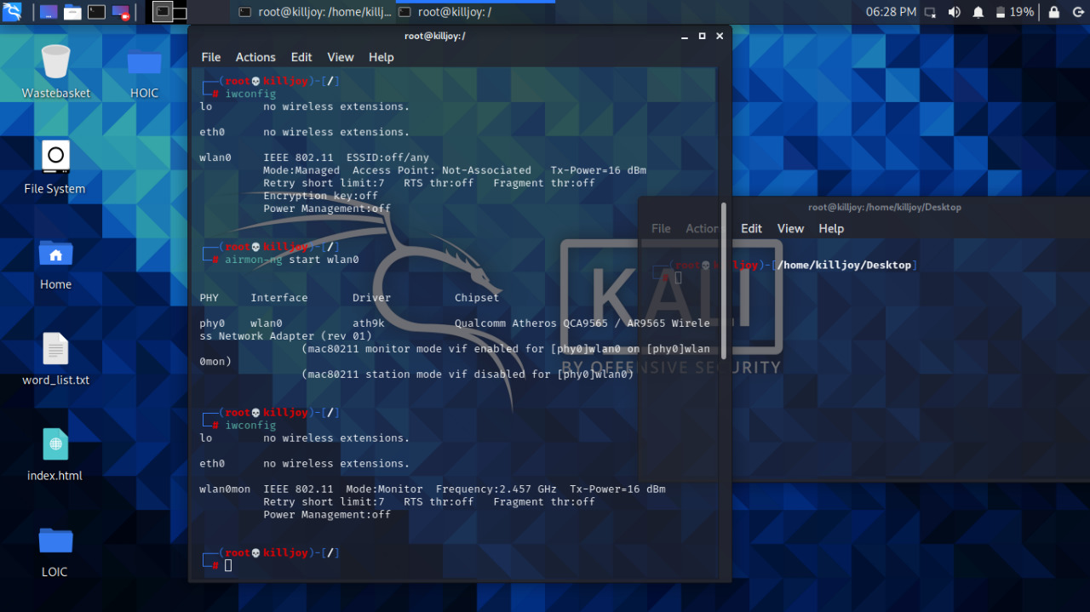

Fig 2.1.1

Step2: Select the target victim and copy the BSSID

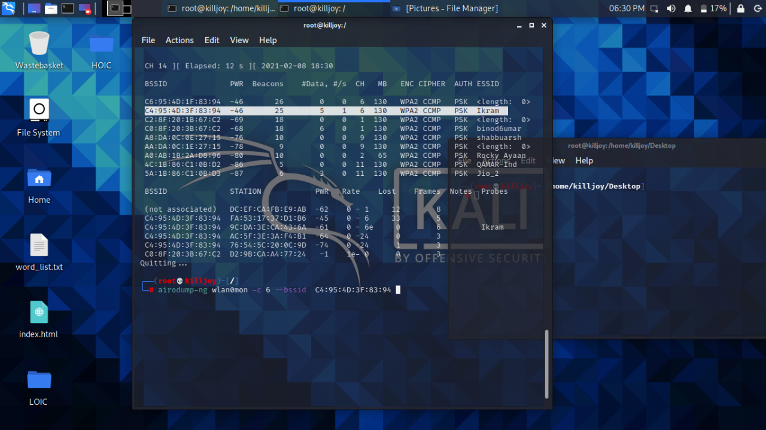

### Fig.2.1.2

Step3:Start airodump-ng to collect authentication handshake

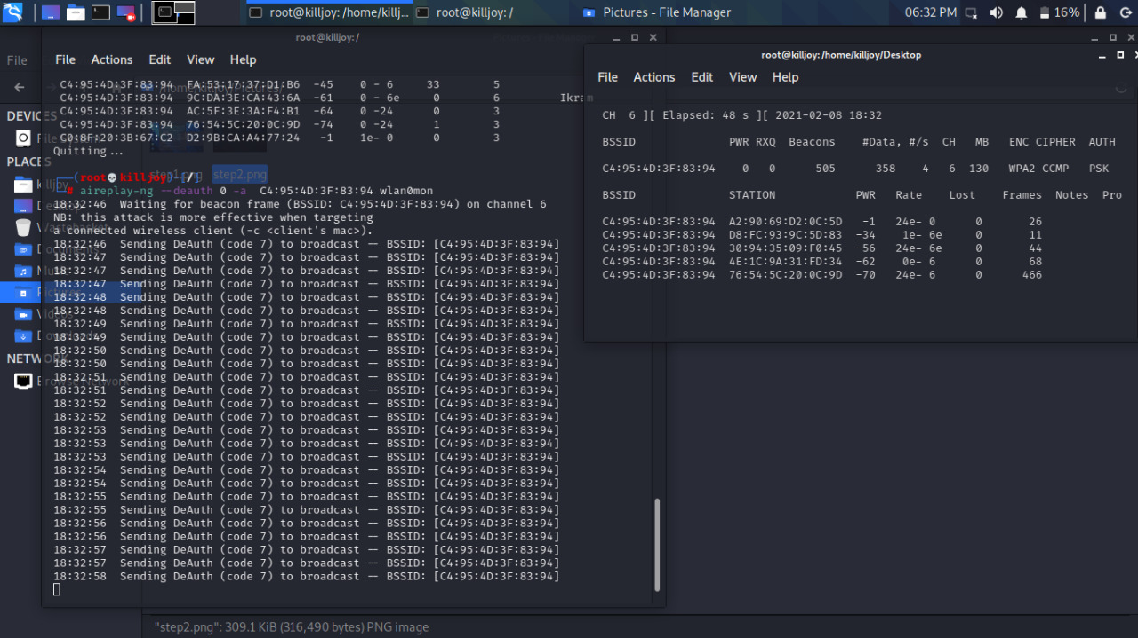

Fig 2.1.3

### Step4: Use aireplay-ng to deauthenticate the wireless client

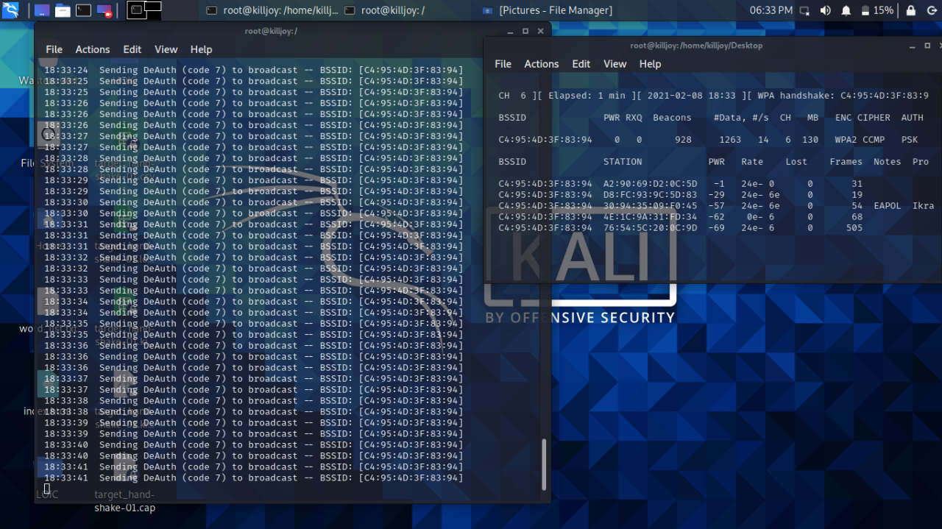

Fig 2.1.4

**2.2Malware Attack**

Step1:Create a payload

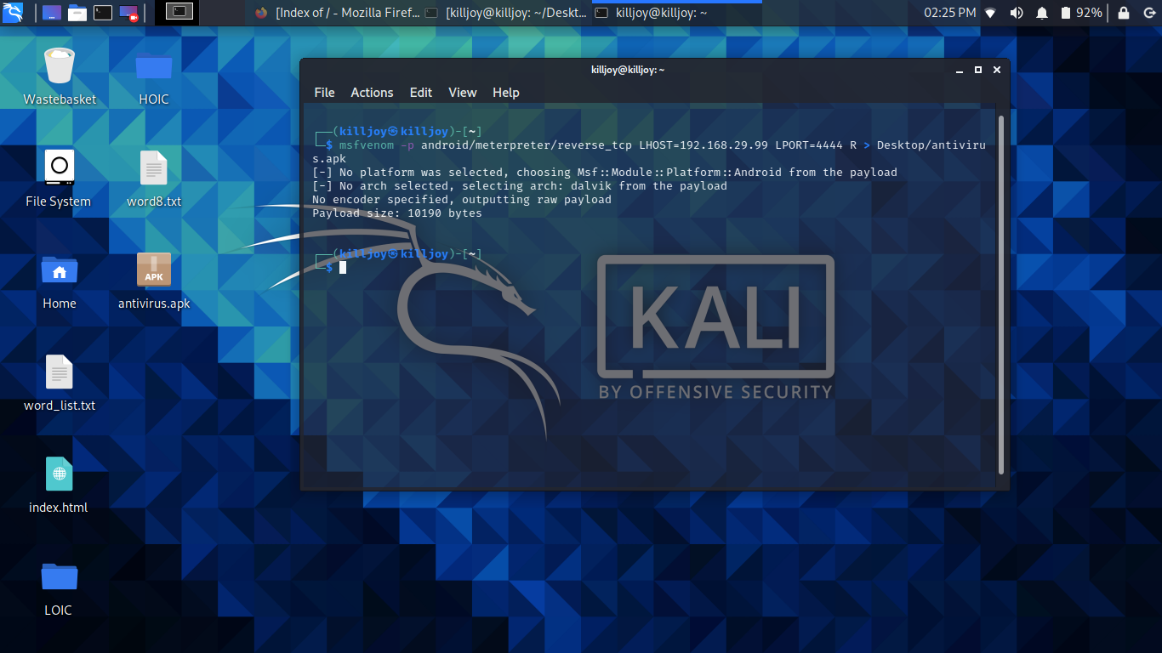

Fig 2.2.1

Step2: After installing the payload to target device ,setting up exploit

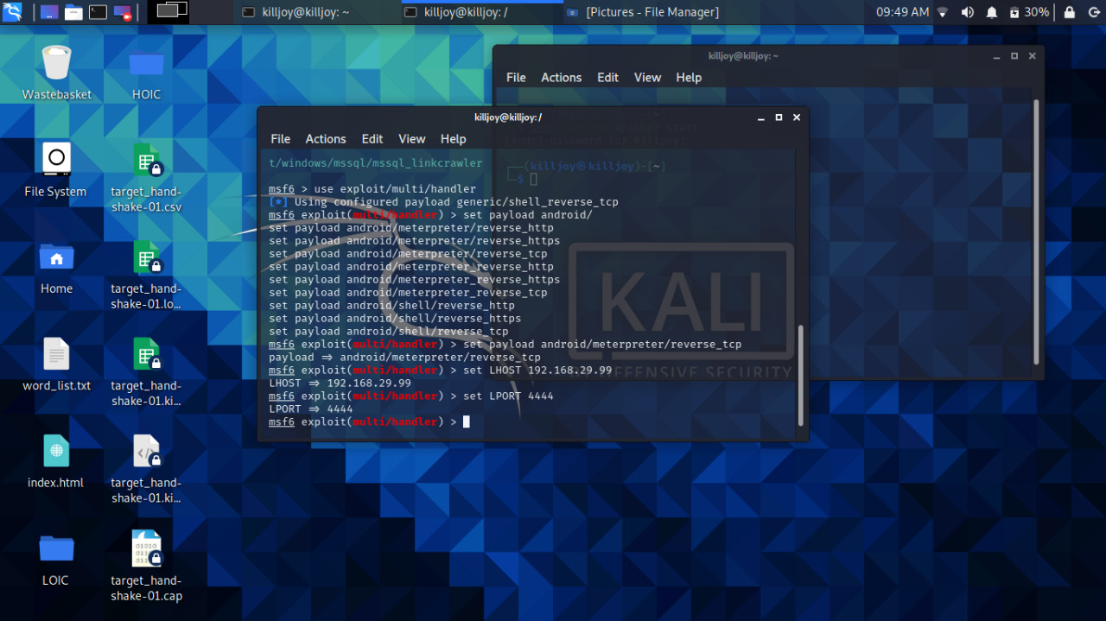

Fig 2.2.2

**2.3DoS attack**

Flooding a private server (192.168.29.240) with HTTP requests . The server becomes slow then later crashes .

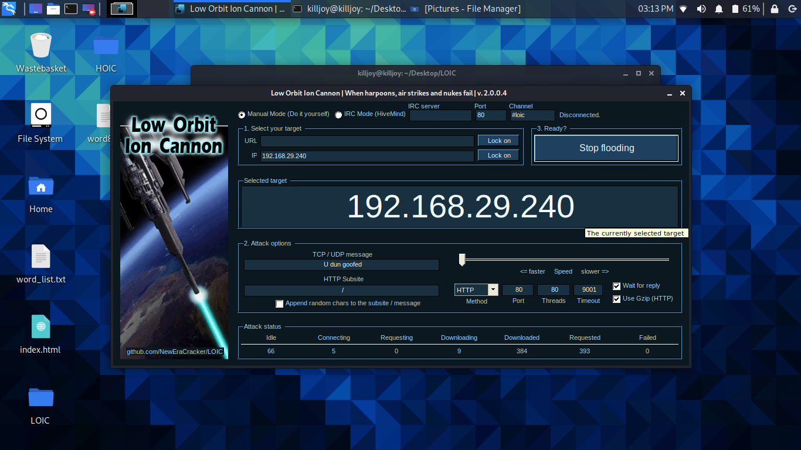

Fig 2.3

**3.RESULT:**

**3.1Dictionary attack**: Run aircrack-ng to crack the pre-shared key.

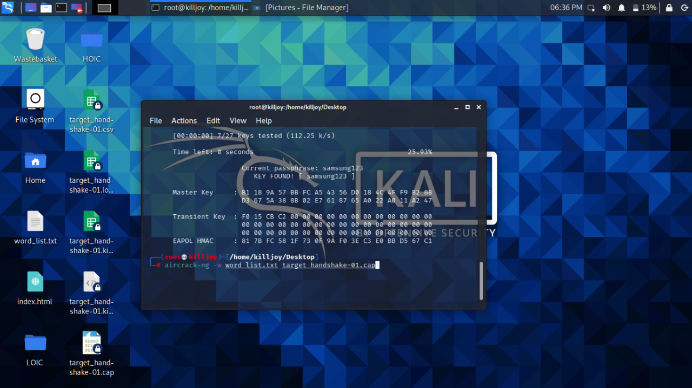

Fig 3.1

**3.2Malware Attack**

**Exploiting the victim device**

Listing installed apps in target device

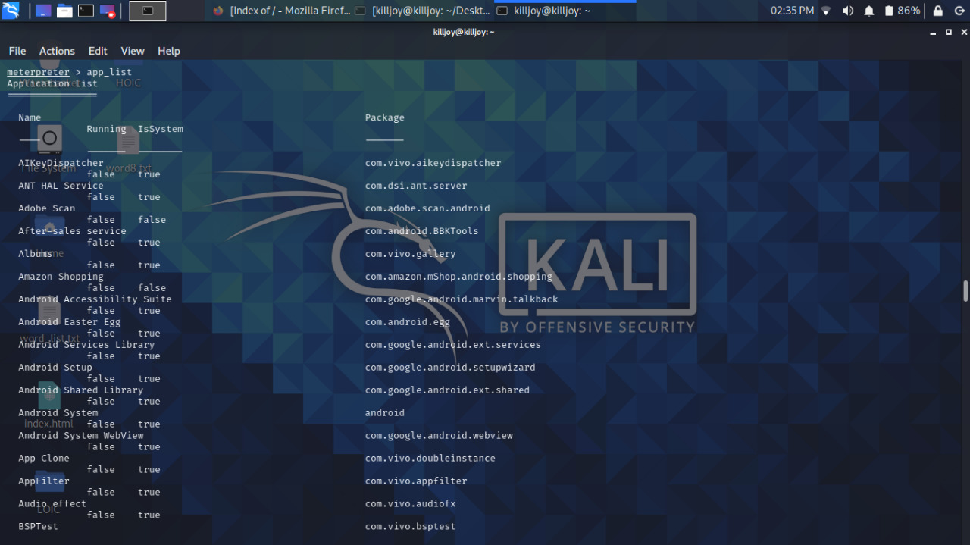

Fig 3.2.1

Taking a web-snap from target device

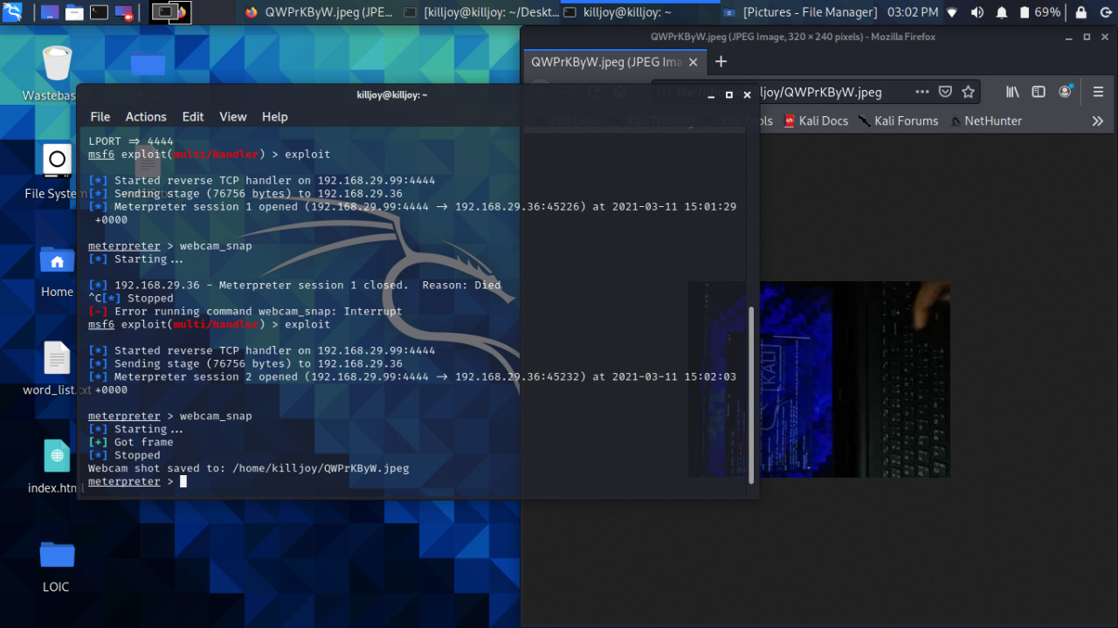

Fig 3.2.2

**4.CONCLUSION:**

 The primary threat to any organization's security is a hacker: learning, understanding, and implementing how hackers operate can help network defenders prioritize potential risks and learn how to remediate them best

Ethical hackers are hired by organizations to look into the vulnerabilities of their systems and networks and develop solutions to prevent data breaches. Consider it a high-tech permutation of the old saying “It takes a thief to catch a thief.”

Ethical hackers are hired by organizations to look into the vulnerabilities of their systems and networks and develop solutions to prevent data breaches. Consider it a high-tech permutation of the old saying “It takes a thief to catch a thief.”

They check for key vulnerabilities include but are not limited to:

* Injection attacks
* Changes in security settings
* Exposure of sensitive data
* Breach in authentication protocols
* Components used in the system or network that may be used as access



Fig 4.1

**5.REFERENCES:**

Axelsson S. Intrusion detection systems: a survey and taxonomy. Technical Report, Chalmers University. Aydın M, Zaim A, Ceylan K. A hybrid intrusion detection system design for computer network security. Computers and Electrical Engineering 2009;35 (3):517–26.

Barber R. Hacking techniques: the tools that hackers use and how they are evolving to become more sophisticated. Computer Fraud and Security 2001;2001 (3):9–12.

Beverly R. A robust classifier for passive TCP/IP fingerprinting. Passive and Active Network Measurement 2004:158–67.

Bhuyan MH, Bhattacharyya DK, Kalita JK. Surveying port scans and their detection methodologies. The Computer Journal 2011a;54:1565–81.

Bhuyan MH, Bhattacharyya DK, Kalita JK. Survey on incremental approaches for network anomaly detection. International Journal of Communication Networks and Information Security 2011b;3(3):226–39.

Bhuyan M, Bhattacharyya D, Kalita J. NADO: network anomaly detection using outlier approach. In: Proceedings of the 1st international conference on communication, computing and security. New York, NY, USA: ACM; 2011c. p. 531–6.

N. Hoque et al. / Journal of Network and Computer Applications 40 (2014) 307–324 323Bhuyan M, Bhattacharyya D, Kalita J. Network anomaly detection: methods, systems and tools. IEEE Communications Surveys and Tutorials Early Access 2013;1:1–34.

Brahmi I, Yahia SB, Poncelet P. MAD-IDS: novel intrusion detection system using mobile agents and data mining approaches. In: Proceedings of the Pacific Asia conference on intelligence and security informatics. Berlin, Heidelberg: Springer-Verlag; 2010. p. 73–6.

Chandola V, Banerjee A, Kumar V. Anomaly detection: a survey. ACM Computing Surveys 2009;41(3):15.

Chen W-H, Hsu S-H, Shen H-P. Application of SVM and ANN for intrusion detection. Computer and Operation Research 2005;32(10):2617–34.

Chen Y, Hwang K, Ku W-S. Collaborative detection of DDoS attacks over multiple network domains. IEEE Transactions on Parallel Distributed Systems 2007;18 (12):1649–62.

Chu J, Ge Z, Huber R, Ji P, Yates J, Yu Y-C. Alert-ID: analyze logs of the network element in real time for intrusion detection. In: Research in attacks, intrusions, and defenses. Springer; 2012. p. 294–313.

Conti G, Abdullah K. Passive visual fingerprinting of network attack tools. In: Proceedings of the 2004 workshop on visualization and data mining for computer security. Washington, DC, USA: ACM; 2004. p. 45–54.

Corona I, Giacinto G, Roli F. Adversarial attacks against intrusion detection systems: taxonomy, solutions and open issues. Information Sciences 2013;239:201–25.